**Battery power**



project 78

Date › june 24th 2019

Name › Andre van der Wacht

Studentnumber › 0948859

Teachers › Ornella Schavemaker-Piva,

Wouter Volders

Opportunity › second opportunity

**Index**

1. Summary p. 2

1.1 Problem p. 2

* 1. Requirements p. 2
  2. Research purpose p. 2
  3. Short conclusion p. 2

1. Introduction p. 3
2. Pre-research p. 4
3. Method p. 5
4. Research/Results p. 6
   1. 9V battery p. 6
   2. AA battery p. 7
   3. Battery recharge module p. 8
   4. Voltage regulator p. 8
   5. Battery power circuit p. 9
5. Conclusion p. 9
6. References p. 10

1. Summary

2.1 Problem

The current project in progress is an arcade console. It will have multiple games like snake and pong. High scores will be saved in a database that will be accessible outside of the console. For the controls there is going to be a wireless controller. The controller will send the input data to the console using Bluetooth. For the controller to be wireless, it will need an internal power supply.

* 1. Requirements

The Arduino requires a 5 volts input to power it. The battery has to be rechargeable, preferably without taking them out of the controller. Last of all, the power consumption and recharging needs to be done without any risk of catching fire or any other problems.

2.3 Research purpose

The purpose of this research is finding the best battery to use for the wireless controller that will be used for the arcade console. The battery has to be rechargeable, have a good capacity and be safe to use, so it will not catch fire. With multiple different sorts of batteries on the market, the goal of this research is to find the suitable battery for the controller.

The method used for this research is literature research. Forums, blogs and article information pages will be used.

2.4 Short Conclusion

The goal was to find the suitable battery for this project. With the results the lithium-ion batteries are the batteries that will be used. The battery is rechargeable and has a good capacity size. To work with the battery safely, a charging module will be used that has a worked in shield against overcharging/draining, the Arduino Charger Module TP4056. This charging module is specifically made for the use of lithium-ion batteries.

The battery has a voltage output of 3.7V. As the Arduino requires 5V to be powered, a step-up voltage regulator will be used to turn the 3.7V into the required 5V. The step-up regulator that will be used is the Pololu 5V Step-Up Voltage Regulator U3V12F5.

2. Introduction

Wireless connections are popular in the world of gaming. Cables are inconvenient and controllers are getting wireless, for example the PlayStation 4 and the Xbox one both got a wireless controller.

This project is about making a new arcade console. This console will have old games like pong and snake for example. But as said, wireless connection is a more convenient option than cable. So that is why we are creating a wireless controller to play the games with. With a wireless controller comes a wireless power supply to power the hardware inside the controller. The power supply needs to be safe so it will not catch fire and needs to power the Arduino, which requires 5V. The purpose of this research is to look into the different sort of batteries and ways to implement them into a wireless device and find the best option for the wireless controller.

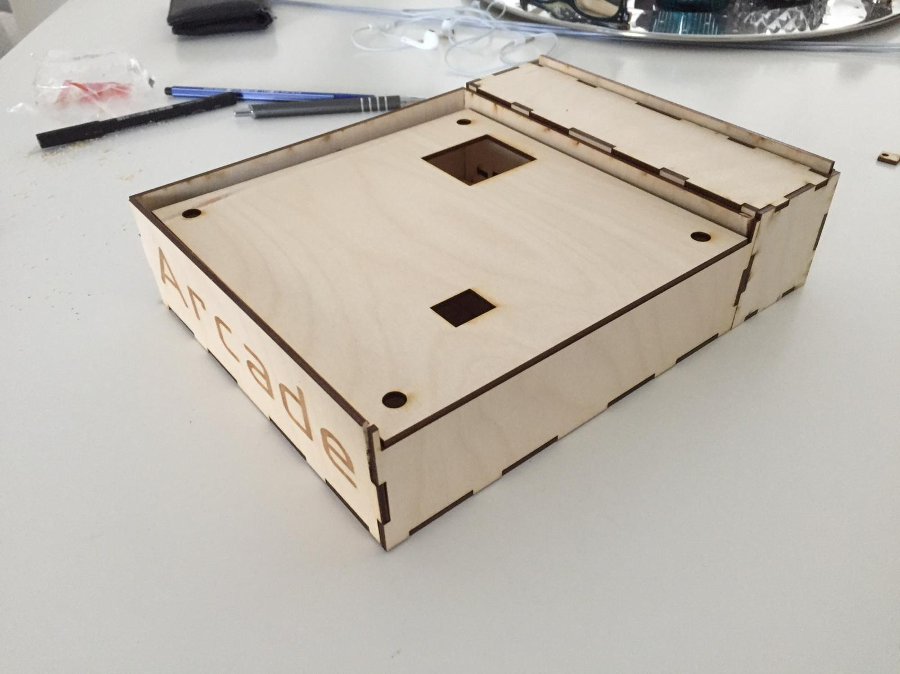

Image 1

3. Pre-research

The requirement of a power supply for a wireless device is not a new topic, it has been since the first wireless device came out. Mobile phones became wireless, so they needed a battery to power the device. Just like the mobile phone, the controller needs its own battery to power it. There are lots of other devices out there which are battery powered, such as: gaming controllers, toothbrushes, watches, the list goes on. But not all devices use the same kind of battery. It all depends on the way the device will be used. For example a PlayStation controller has a closed shell to protect its hardware, including the battery. This means you cannot take the battery out to change it. To prevent that you will have to buy a new controller every time the battery is empty, the controller has a rechargeable battery. This way the player can charge the controller when he/she is not playing or even while playing. This is exactly what is needed for the controller in this project. The battery in a PlayStation controller does not have a huge capacity, around 650mAh. Considering that the controller will not be optimized in its power consumption. This battery would not be a good fit for the current controller.

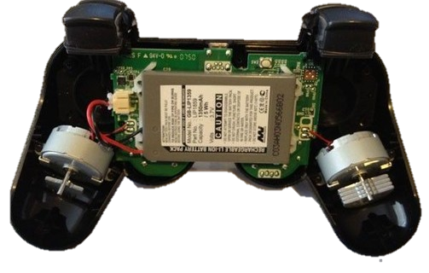

Image 2

Another solution would be to use a power bank. Power banks have a good capacity in general, but power banks have a downside when to be used in a custom project. The power bank already has its output and input ports on a certain location. This made it difficult to implement it inside the controller. Even though the power bank itself would not work, the inside of the power bank was a good example to look at.

. 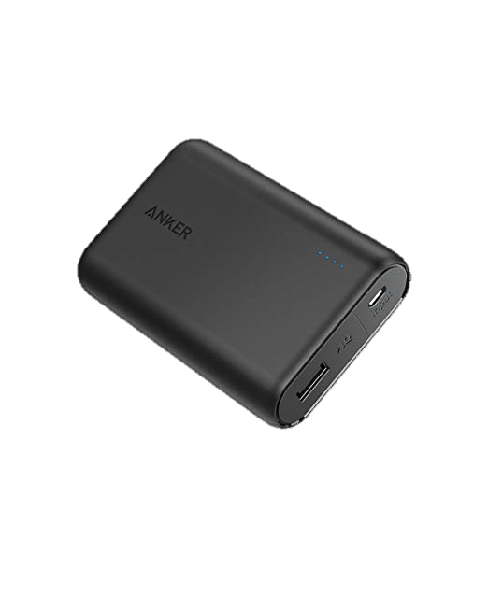

Image 3

4. Method

For this project’s controller the goal is to make it wireless, to make this work, a battery power supply will be needed. The battery should be rechargeable, have a decent capacity and have an output of 5V to be able to meet the requirement of 5V for the Arduino to be powered. To find out which battery is the best option for the controller, forums, blogs and other websites will be used.

5. Research/Results

5.1 9V battery[4]

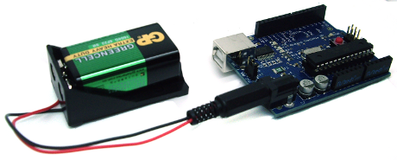

Image 4

|  |  |  |  |  |  |  |
| --- | --- | --- | --- | --- | --- | --- |
| **9V Battery** | [**Alkaline**](https://en.wikipedia.org/wiki/Zinc%E2%80%93carbon_battery) | **Zinc-carbon** | **Lithium** | **NiMH** | **Lithium polymer** | **Lithium-ion** |
| **Capacity** | 550  [mAh](https://en.wikipedia.org/wiki/Ampere_hour) | 400  [mAh](https://en.wikipedia.org/wiki/Ampere_hour) | 1200  [mAh](https://en.wikipedia.org/wiki/Ampere_hour) | 175-300  [mAh](https://en.wikipedia.org/wiki/Ampere_hour) | 520  [mAh](https://en.wikipedia.org/wiki/Ampere_hour) | 620  [mAh](https://en.wikipedia.org/wiki/Ampere_hour) |
| [**Voltage**](https://en.wikipedia.org/wiki/Voltage) | 9 V | 9 V | 9 V | 7.2-9.6 V | 7.4 V | 7.4 V |
| **Rechargeable** | No | No | No | Yes | Yes | Yes |
| **Price p.p.** | €1.95 | €1.95 | €6.95 | €7.95 | €7.49 | €6.90 |

5.2 AA batteries[3,5]

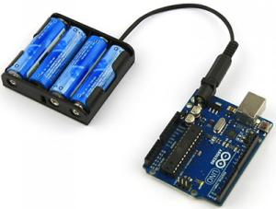

Image 5

|  |  |  |  |  |  |  |  |
| --- | --- | --- | --- | --- | --- | --- | --- |
| [**AA**](https://en.wikipedia.org/wiki/Comparison_of_commercial_battery_types) **Battery** | [**Zinc–Carbon**](https://en.wikipedia.org/wiki/Zinc%E2%80%93carbon_battery) | [**Alkaline**](https://en.wikipedia.org/wiki/Alkaline_battery) | [**Li-FeS**](https://en.wikipedia.org/wiki/Lithium_battery) | [**Li-ion**](https://en.wikipedia.org/wiki/Lithium-ion_battery) | [**NiCd**](https://en.wikipedia.org/wiki/Nickel%E2%80%93cadmium_battery) | [**NiMH**](https://en.wikipedia.org/wiki/Nickel%E2%80%93metal_hydride_battery) | [**NiZn**](https://en.wikipedia.org/wiki/Nickel%E2%80%93zinc_battery) |
| **Capacity** | 400–1700  [mAh](https://en.wikipedia.org/wiki/Ampere_hour) | 1800-2850  [mAh](https://en.wikipedia.org/wiki/Ampere_hour) | 2700-3400  [mAh](https://en.wikipedia.org/wiki/Ampere_hour) | 600-3300  [mAh](https://en.wikipedia.org/wiki/Ampere_hour) | 600-1000  [mAh](https://en.wikipedia.org/wiki/Ampere_hour) | 600-2750  [mAh](https://en.wikipedia.org/wiki/Ampere_hour) | 1500-2500  [mAh](https://en.wikipedia.org/wiki/Ampere_hour) |
| [**Voltage**](https://en.wikipedia.org/wiki/Voltage) | 1.5 V | 1.5 V | 1.5 V | 3.6-3.7 V | 1.2 V | 1.2 V | 1.6-1.65 V |
| **Rechargeable** | No | [Some](https://en.wikipedia.org/wiki/Rechargeable_alkaline_battery) | No | Yes | Yes | Yes | Yes |
| **Price p.p.** | €0.29 | €0.38 | €2.99 | €3.20 | €1.20 | €1.82 | €3.11 |

The batteries will be used for the controller of the arcade machine. There are 2 possibilities to work with:

Non-rechargeable batteries, which need to be replaced when they are empty.

OR

Rechargeable batteries, which can be charged when they are empty, which means there is no need for the batteries to be removable.

After comparing the 2 battery options there are, rechargeable and non-rechargeable, we have chosen to go for the rechargeable batteries. This way we can fully integrate the battery into the controller. With built in rechargeable batteries you will need a way to recharge them without having to take them out.

First the decision had to be made which battery would be used. The battery of choice is the Li-ion AA battery. The AA battery has been chosen as the 9V battery provides a too high current, this will only cause a loss of power, which is a waste. The Li-ion battery has been chosen, because it has a higher voltage output than other AA-batteries. The Bluetooth module in use is the HC-06. The module needs a 3.3V input. The Li-ion battery gives enough voltage to work with.

The Arduino Uno on the other hand, requires a minimum of 5V. This can be achieved with a voltage step-up regulator.

5.3 Battery recharge module[2]

The Arduino Charger Module TP4056 is specifically designed to charge Li-ion batteries. The module makes sure the batteries output and input are safe and will prevent the battery fromcatching fire. Now we have a battery to use and a way to safely recharge it, we need one more thing for the circuit to be fully operational and safe. The voltage regulator.

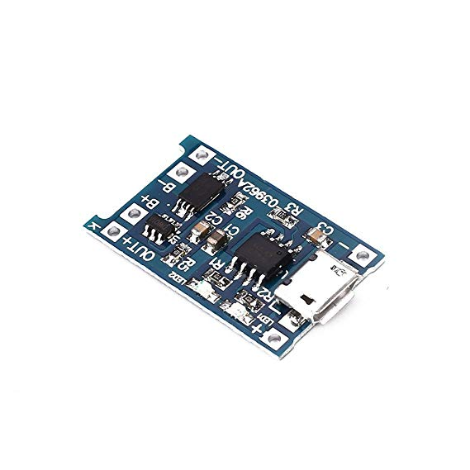

Image 6

5.4 Voltage Regulator[1]

The Pololu 5V Step-Up Voltage Regulator U3V12F5 is a small regulator is a small board that is able to boost our 3.6V output to a 5V output, exactly what we need. Besides the fact the board does what we need, the fact that the board is so small makes it ideal to use in a controller. This way all the hardware can fit inside the controller without big problems and doesn’t affect our controller design.

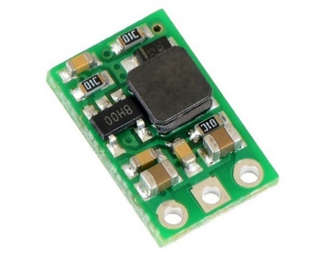

Image 7

5.5 Battery Power circuit

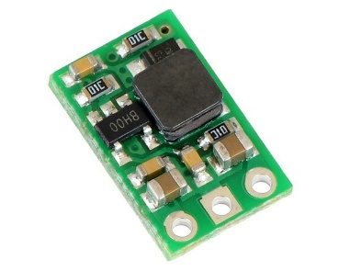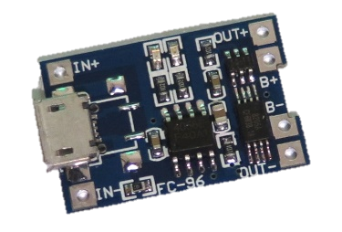

5V

3.6V

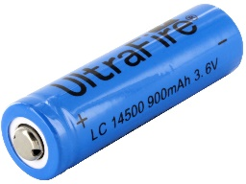

GND

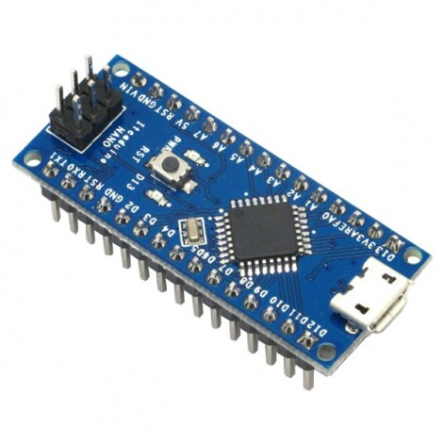

GND

GND

Image 8

The + from the battery is connected to the BAT Vin, and the – is connected to the BAT gnd.

The 3.6 V will be sent to the Vout that is connected to the step-up regulator. The ground of the step-up regulator is connected to the gnd on the charger module that will send it to the – on the battery. Last of all the step-up regulator will send the 5V to the Arduino to power it.

6. Conclusion

The purpose of this research was to find a battery that was preferably rechargeable, has a good capacity, is able to deliver the required 5V for the Arduino and the battery has to be safe to work with. The Li-ion is the best choice to use for the controller, this is based on the higher voltage output than other AA batteries, but not too high and the ability to recharge it. To work with this battery, the Arduino Charger Module 18650 is a perfect module/shield to work with. It protects the battery from overcharging and makes sure the output is right. This way the battery will not catch fire. To boost the 3.6V output of the battery, the Pololu 5V Step-Up Voltage Regulator U3V12F5 seems to be the perfect fit. It is a small board that is able to boost a minimum of 2.5V up to 5V. Putting these pieces together in a circuit results in a safe, compact and rechargeable power supply to use in the controller.

7. References

[1] Pololu Robotics&Electronics. Pololu 5V Step-Up Voltage Regulator U3V12F5.

Available: <https://www.pololu.com/product/2115>

[2] Ruben. may 17, 2018. Power Your Projects With a Built-In Lithium Battery and a TP4056 Charger. Available: <https://rlopezxl.com/2018/05/17/power-your-projects-with-a-built-in-lithium-battery-and-a-tp4056-charger/>

[3] june 28, 2018. Do Rechargeable Lithium-Ion AA Batteries Exist? Available: <https://reactual.com/portable-electronics/batteries-portable-electronics/do-rechargeable-lithium-ion-aa-batteries-exist.html>

[4] Andrea Cannon. november 19, 2015. The 5 Best 9 Volt Batteries. Available: <https://www.wisebread.com/the-5-best-9-volt-batteries>

[5] RS components. Everything You Need To Know About AA Batteries. Available:

<https://au.rs-online.com/web/generalDisplay.html?id=ideas-and-advice/aa-batteries-guide>

[6] image 1: arcade64 design, made by Ramon

[7] Image 2: controller: Available

<https://yaoota.com/en-sa/product/playstation-3-controller-replacement-battery-high-capacity-p-price-from-souq-saudi-arabia>

[8] Image 3: powerbank. Available:

<https://www.amazon.com/Anker-PowerCore-Ultra-Compact-High-Speed-Technology/dp/B0194WDVHI>

[9] Image 4: 9V battery power. Available:

<https://webshop.clevercircuits.com/product/battery-9v-battery-holder/>

[10] Image 5: AA battery power. Available:

<https://hwstartup.wordpress.com/2013/04/15/how-to-run-an-arduino-clone-on-aa-batteries-for-over-a-year-part-2/>

[11] Image 6: Battery Recharge module. Available:

<https://www.tinytronics.nl/shop/nl/batterij-en-accu/laders/tp4056-micro-usb-li-ion-lader-1a-met-li-ion-protection-circuit>

[12] Image 7: Step-up Regulator. Available:

<http://www.us.diigiit.com/pololu-step-up-voltage-regulator-u3v12f5>

[13] Image 8: Battery power circuit components. Available:

Battery: <https://www.batteryjunction.com/14500.html>

Arduino: <https://troncart.com/arduino-accessories/52-clone-arduino-nano.html>

Step-up Regulator: <http://www.us.diigiit.com/pololu-step-up-voltage-regulator-u3v12f5>

Battery recharge module: <https://www.tinytronics.nl/shop/nl/batterij-en-accu/laders/tp4056-micro-usb-li-ion-lader-1a-met-li-ion-protection-circuit>

[14] front page image, battery power. Available:

<https://www.alphr.com/mobile-phones/1007440/dos-and-don-ts-for-better-battery-life>

[15] Umair Hussaini, September 21, 2017, Four ways to power the Arduino. Available:

<https://www.technobyte.org/2016/07/power-up-the-arduino-uno/>